**Task-6 part-3**

**1.**

**aa = (f,s,t) => {**

**console.log(f,s,t);**

**if(f>s &&f>t){**

**console.log(f)}**

**else if(s>f && s>t){**

**console.log(s)}**

**else{**

**console.log(t)}**

**}**

**aa(1,2,3);**

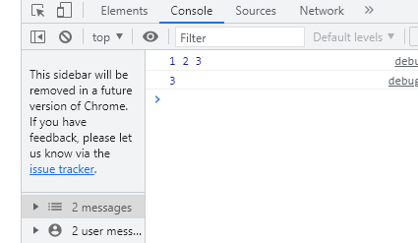

**2.**

**let n = [1,2,3];**

**console.log(add(n));**

**function add(n)**

**{**

**let sum = 10;**

**for(var i=0;i<n.length;i++){**

**sum+=n[i]**

**}**

**return sum;**

**}**

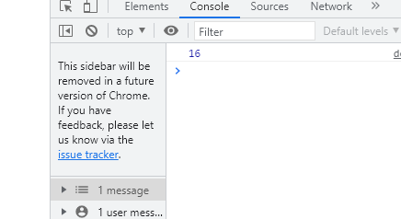

**3.**

**(function() {**

**const arr =[9,8,5,6,4,3,2,1];**

**let sum = 0;**

**for (var i = 0; i <= arr.length; i++){**

**sum += arr[i];**

**console.log(sum);}**

**return sum;**

**})();**

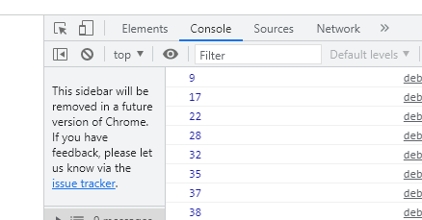

**4.**

**var arr = ["guvi", "geek", "zen", "fullstack"];**

**var ano = function(arro) {**

**for (var i = 0; i <= arr.length; i++) {**

**console.log(arr[i][0].toUpperCase() + arr[i].substr(1));**

**}**

**}**

**ano();**

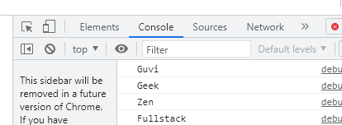

**5.**

**const newArray=[1,3,2,5,10,13];**

**const myPrime=newArray.filter(num=>{**

**for(let i=2;i<=num;i++){**

**if(num%i===0)**

**{**

**return true;**

**}**

**}**

**return false;**

**});**

**console.log(myPrime);**

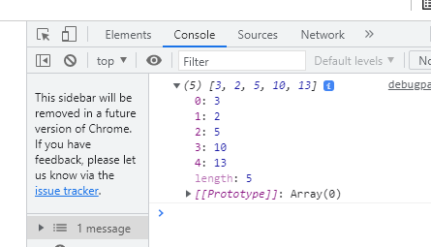

**6.**

**const num = [10, 20, 30, 40,50,60,70,80,90,100]**

**sum = num.reduce((a,b)=>a+b,0)**

**console.log(sum);**

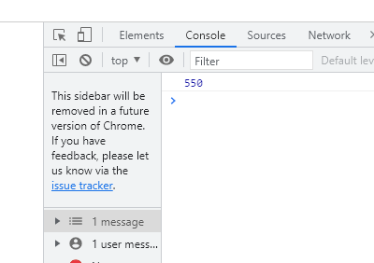

**7.**

**(function() {**

**var arr = [1, 2, 3, 6, 8, 6, 1, 9, 10, 12, 13];**

**var k = 3;**

**k = arr.length % k;**

**const arr1 = {};**

**out = arr.slice(k + 1, arr.length);**

**var count = out.length;**

**for (var i = 0; i < k + 1; i++) {**

**out[count] = arr[i];**

**count += 1;**

**}**

**console.log(out);})();**

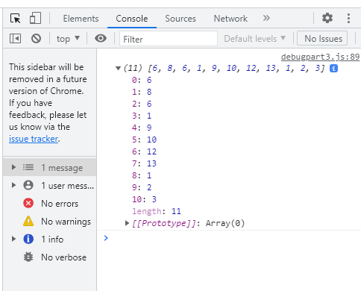

**8.**

**var arr = ["guvi", "geek", "zen", "fullstack"];**

**(function() {**

**for (var i = 0; i <= arr.length; i++) {**

**console.log(arr[i][0].toUpperCase() + arr[i].substr(1));**

**}**

**})();**

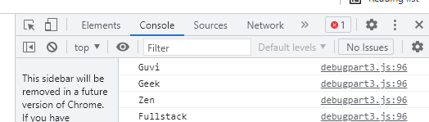

**9.**

**var arr = [1, 2, 3, 5, 7, 79, 7, 2, 6, 9, 4];**

**(function() {**

**for (var i = 0; i < arr.length; i++) {**

**if (arr[i] % 2 !=0) {**

**console.log(arr[i]);**

**}}**

**})();**

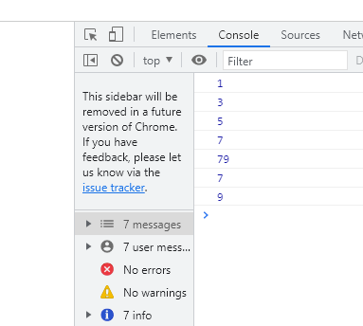

**10.**

**(function() {**

**var str="abcd";**

**str1 = str.split("").reverse().join("");**

**console.log (str1);**

**})();**

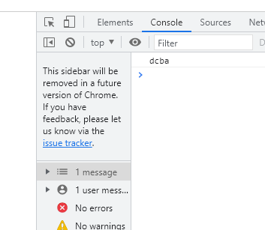

**11.**

**var res = function(arr){**

**for(var i=0; i < arr.length; i++){**

**var newArr = [];**

**if(newArr.indexOf(arr[i]) === -1) {**

**newArr.push(arr[i]);**

**} }**

**console.log(newArr)**

**}**

**res(["guvi","geek","guvi","duplicate","geeK"])**

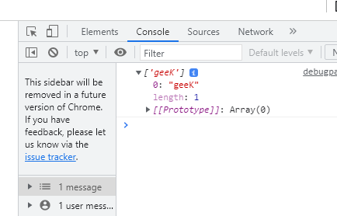

**12.**

**var as=[12,34,5,6,2,56,6,2,1];**

**var s=as.reduce(function(a,c){**

**if(a%2!=0)**

**{**

**return a+c;**

**}**

**return a;});**

**console.log(s);**

